Successful HopkinsPD Installation in Andriod 6.0

Step 1. Install the apk file

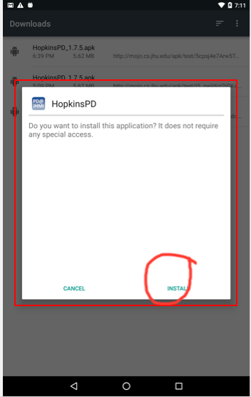

Step 2. Click DONE when it installed (DO NOT OPEN IT NOW)

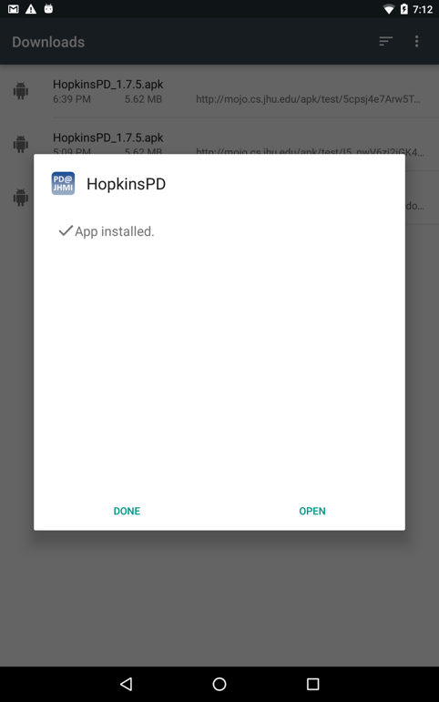

Step 3. Find and click settings

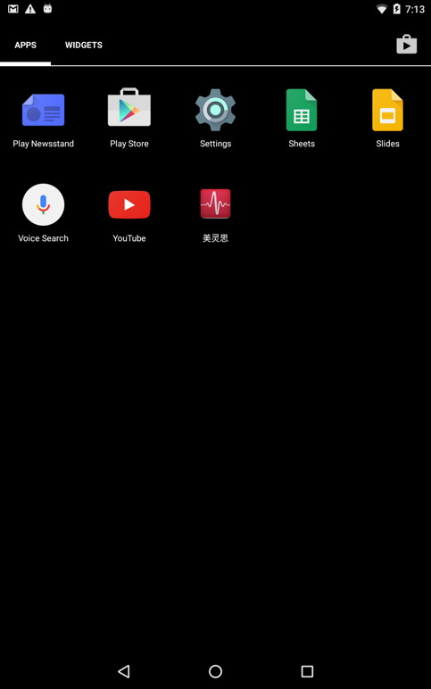

Step 4. Click apps

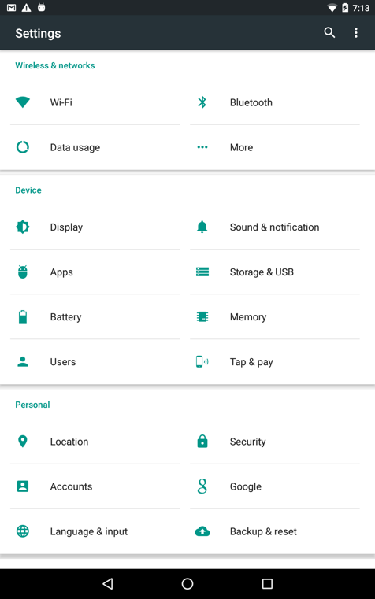

Step 5. Find and clink HopkinsPD

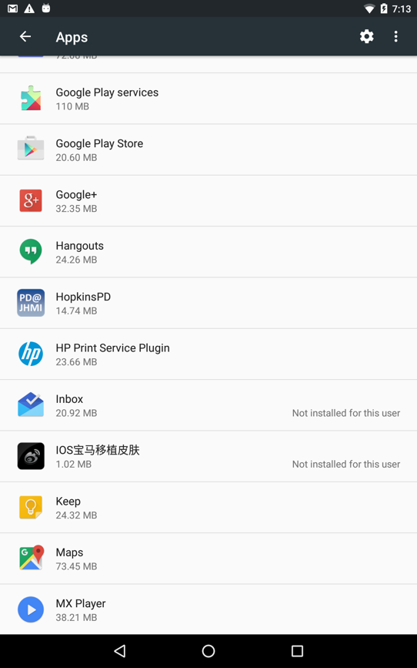

Step 6. Click permissions

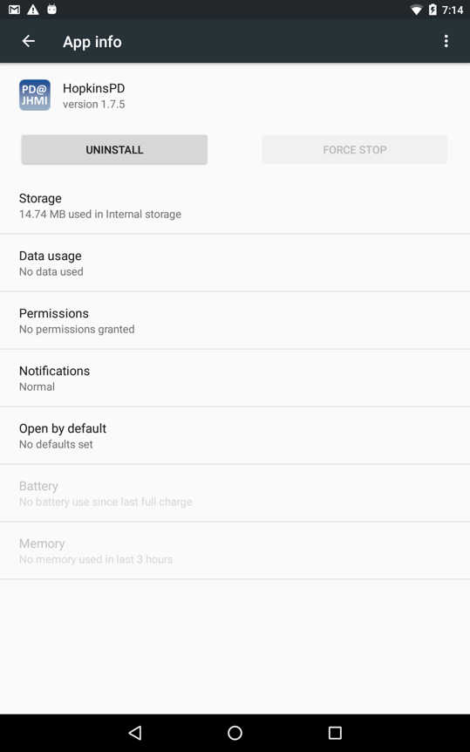

Step 7. Enable all permissions

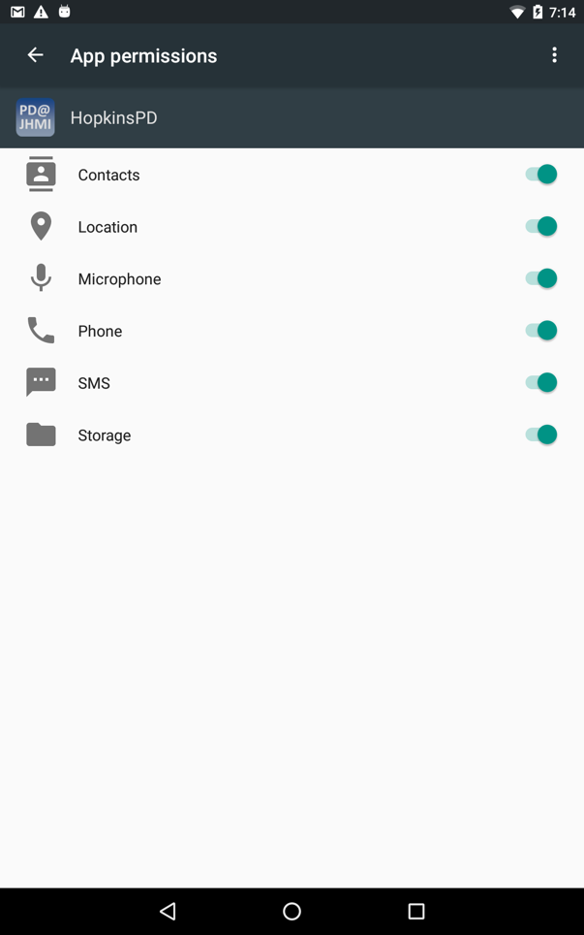

Step 8. Open HopkinsPD app and it should works now!